**Hands on – Joins and Subqueries**

**Hands on Name: Book The Show**

**Description:**

BookTheShow Corporation tells you to build an automated movie booking system so that they can track the movie details, the customer details and the movie tickets booked by the customers on respective movie complex. Using the schema given below write necessary queries to help BookTheShow Corporation to find the necessary information’s required by the organization.

**Schema Name: dbBookTheShow**

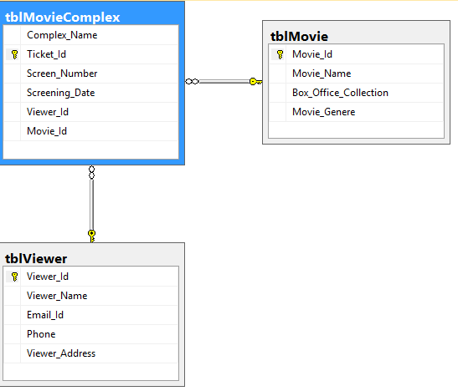

**Refer to the sample data below:**

|  |  |  |  |
| --- | --- | --- | --- |
| **Table: tblMovie** | | | |
| **Movie_Id** | **Movie_Name** | **Box_Office_Collection** | **Movie_Genere** |
| M001 | Rocky Rambo | 5 Crore | Action |
| M002 | Harry Porter | 10 Crore | Fantasy |
| M003 | The Magical Beast | 8 Crore | Fantasy |
| M004 | Transporter2 | 11 Crore | Action |
| M005 | A Beautiful Mind | 18 Crore | Romantic |
| M006 | Transformer | 12 Crore | Fantasy |

|  |  |  |  |  |
| --- | --- | --- | --- | --- |
| **Table: tblViewer** | | | | |
| **Viewer_Id** | **Viewer_Name** | **Email_Id** | **Phone** | **Viewer_Address** |
| V001 | Sam | sam@yahoo.in | 9600197755 | Coimbatore-Tamil Nadu-600111 |
| V002 | Joe | joe@gmail.com | 8794561230 | Chennai-Tamil Nadu-603102 |
| V003 | Merry | merry@gmail.com | 7682458976 | Kolkata-West Bengal-700001 |
| V004 | Tom | tom@yahoo.co.in | 9600197758 | Madurai-Tamil Nadu-600117 |
| V005 | Hari | hari@gmail.com | 8521479630 | Durgapur-West Bengal-713212 |

|  |  |  |  |  |  |
| --- | --- | --- | --- | --- | --- |
| **Table: tblMovieComplex** | | | | | |
| **Complex_Name** | **Ticket_Id** | **Screen_Number** | **Screening_Date** | **Viewer_Id** | **Movie_Id** |
| Inox Forum | IN001 | 3 | 2/20/2018 | V003 | M005 |
| Inox Forum | IN002 | 1 | 3/15/2018 | V001 | M002 |
| Inox Escape Mall | IN003 | 2 | 4/25/2018 | V005 | M001 |
| Inox Escape Mall | IN004 | 1 | 4/25/2018 | V003 | M005 |
| PVR Cinema | PC001 | 4 | 4/21/2018 | V001 | M005 |
| PVR Escape Mall | V001 | 2 | 2/20/2018 | V001 | M002 |

**Now based on the above schema and sample records solve the below queries:**

1. Display the movie id, movie name and complex name which are running the movie for those movies whose name starts with T in descending order by movie name length. Display the movie name and complex name in upper case. [If the movie is not running in any movie complex, display the complex side as null].

**[Note: Order of columns for display is as per given in question]**

2. Display the viewer name, email id, phone, address and movie names that the viewer has booked ticket. If a viewer has not booked any ticket display the movie name null.

Display data in ascending order by viewer name.

**[Note: Order of columns for display is as per given in question]**

3. Display the movie name and count how many users have seen each movie[Use alias called Movie_Count]. Display datain descending order by movie name.

Note: Display Movie Count as 0 if a movie is still not viewed by any viewer.

**[Note: Order of columns for display is as per given in question]**

4. Display the movie name, movie genere, viewer name,email,phone,complex name,ticket id in first descending orderby monthname of screening date and then in ascending order by movie name.

[Hint: Use datename(month,column_name) function to extract month name in string format]

**[Note: Order of columns for display is as per given in question]**

5. Due to rain the all movies screening dates for all movie complexeshave been deferred by 4 days. Hence display the movie name,moviecomplex name, screening date as alias Proposed_Screening_Date and deferreddate as alias Actual_Screening_Date in descending order by movie name.[Display the Proposed_Screening_Date and Actual_Screening_Date in theformat as in example: Thursday,18 May,18].

[Hint: Use Format(Table_Name.Column_Name,'dddd,dd MMMM,yy') function to display date value according to the format asked in question].

**[Note: Order of columns for display is as per given in question]**

Q6. Display the name, email Id and phone number of viewers who have not booked ticket in any movie complex in descending order by viewer name.

[Note: Use Subquery for this problem statement]

**[Note: Order of columns for display is as per given in question]**